# Interview Coding Example

## Existing Model

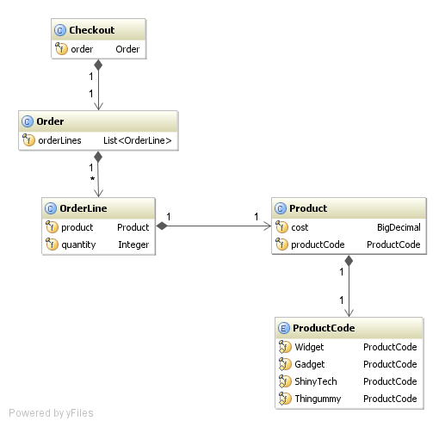

## Features to Add

Apply the following discounts to the order total:

1. 10% for orders totalling 50 or more
2. 3 items for the price of 2 when buying multiple items of the same product
3. Discount voucher